**Initial Design:**

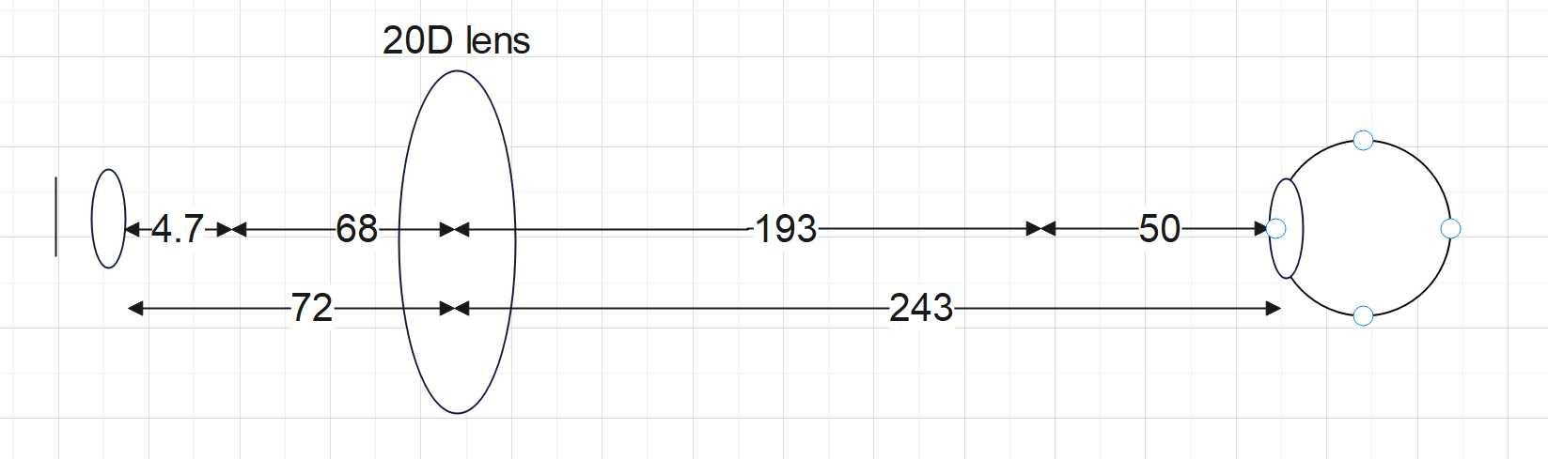

This design was created in person using cardboard and a string to move the lens. The photo of the prototype and the photo we took using this setup can be seen below.

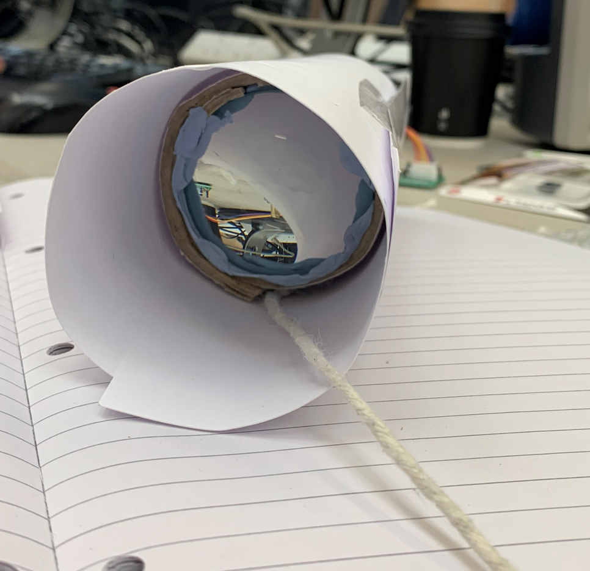

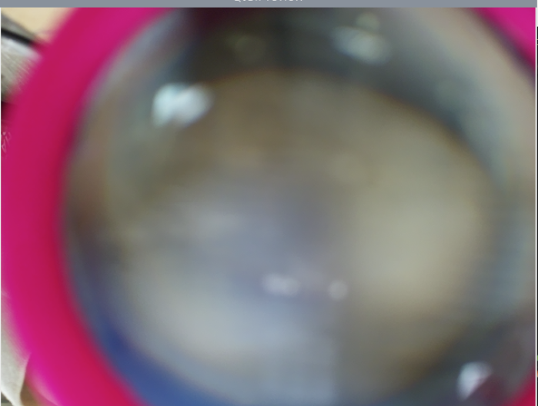

Conclude: Although a short distance of only around 30cm which fits the constraint, the photo taken was not focused. This was expected as the distance between the eye and the lens is very large. There is a lot of room for distortion.

**Second Design with much stronger lens:**

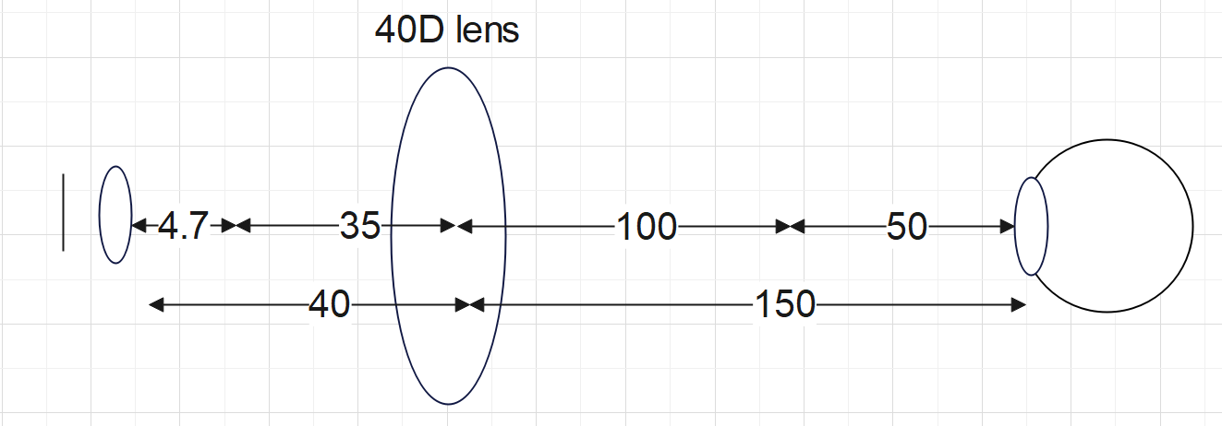

This lens setup was not realised due to the cost of the 40D lens. The price of the 40D is around £100 if not bought second hand, which does not fit the specification. They are much less standard than the 20D lens which is one of the most available lenses. In theory, this design would be quite good as the distance between the eye and the lens is shorter, leaving less room for distortion and the overall length is less than 20cm!

**Final Lens Design:**

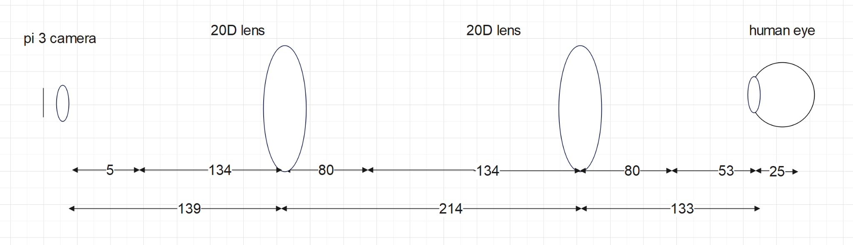

This design was created in person using cardboard and was also used in the final prototype. The photos of the initial prototype, final prototype and a photo we took using this setup can be seen below.

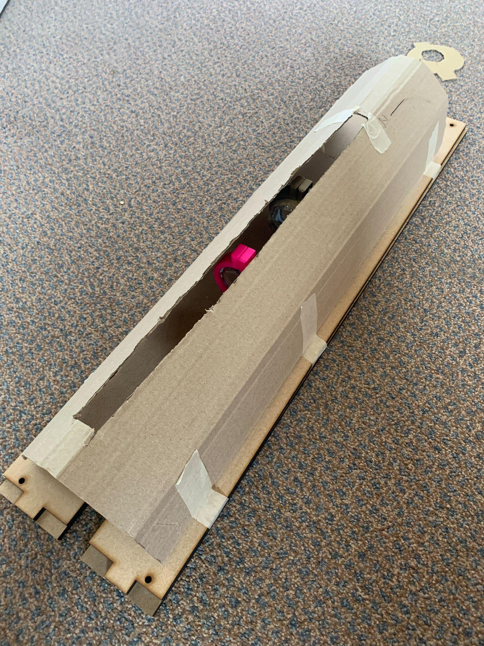

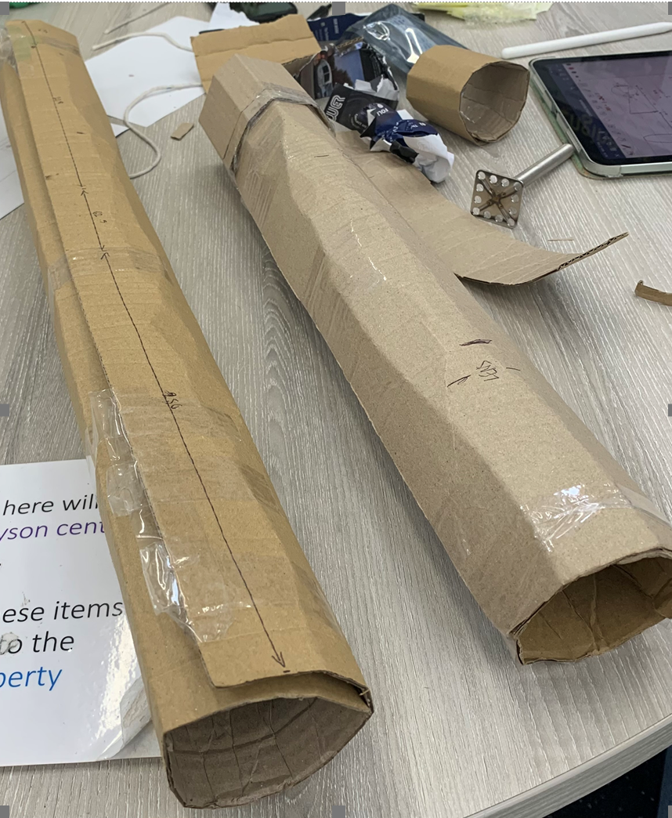

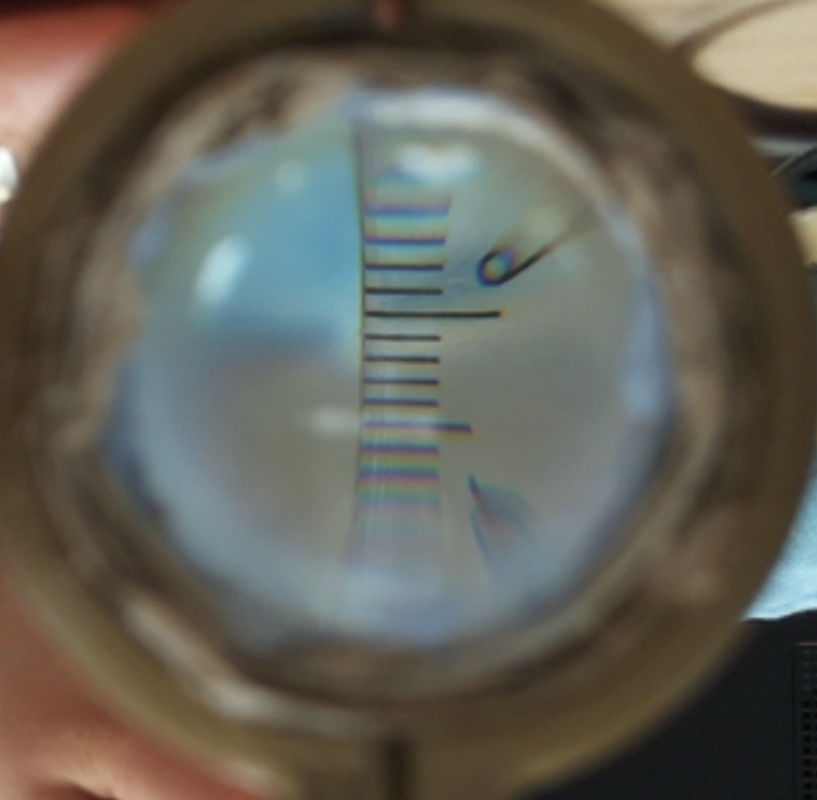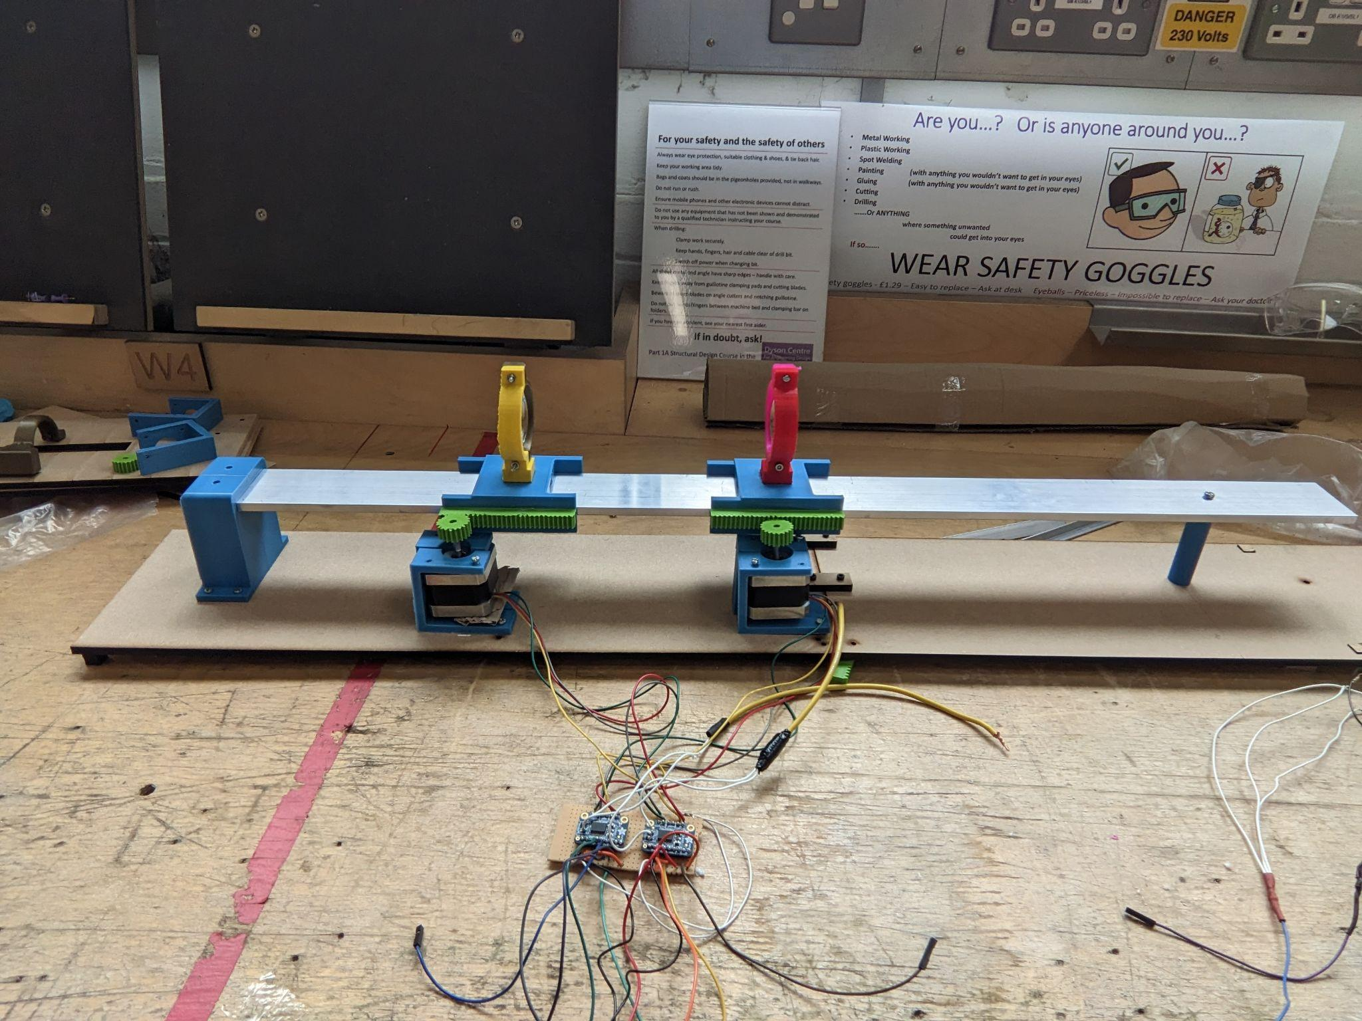

This setup was chosen as the final design because although it reached around 50cm, the photo is much more focused and the lenses used are 20D, which are again very standard, readily available and cheap. The use of 2 lenses means we have to treat one as a zooming lens and the other as a focusing lens. This complicates the focusing method but this has been addressed using pseudocode.